1. Write the programme to sort the integers 8, 4, 3,5,6 and the alphabetical string C, O, I, P, U, in ascending order. Show the resulting output.

# CODE :

**package** Hellow;

**import** java.util.Arrays;

**public class** SortArrays {

**public static void** main(String[] args) {

// Integer array

**int**[] intArray = {8, 4, 3, 5, 6};

// String array

String[] strArray = {"C", "O", "I", "P", "U"};

// Sort the integer array Arrays.*sort*(intArray);

// Sort the string array Arrays.*sort*(strArray);

// Print sorted integer array System.***out***.print("Sorted integers values is : "); **for** (**int** num : intArray) {

System.***out***.print(num + " ");

}

System.***out***.println();

// Print sorted string array System.***out***.print("Sorted strings values is: "); **for** (String str : strArray) {

System.***out***.print(str + " ");

}

}

}

# OUTPUT :

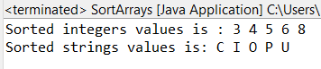

1. Write a Java program to implement the bubble sort algorithm to sort an array of integers in ascending order.

# CODE :

**package** Hellow;

**public class** BubbleSort {

**public static void** main(String[] args) {

// Array of integers to be sorted

**int**[] intArray = {8, 4, 3, 5, 6, 7, 9};

// Perform bubble sort

*bubbleSort*(intArray);

// Print the sorted array System.***out***.print("Sorted array: "); **for** (**int** num : intArray) {

System.***out***.print(num + " ");

}

}

// Bubble sort algorithm

**public static void** bubbleSort(**int**[] array) {

**int** n = array.length;

**boolean** swapped;

// Traverse through all elements in the array

**for** (**int** i = 0; i < n - 1; i++) { swapped = **false**;

// Last i elements are already sorted, no need to check them

**for** (**int** j = 0; j < n - 1 - i; j++) {

// Swap if the current element is greater than next element

**if** (array[j] > array[j + 1]) { **int** temp = array[j]; array[j] = array[j + 1]; array[j + 1] = temp; swapped = **true**;

}

}

// If no two elements were swapped in inner loop,the array is sorted

**if** (!swapped) **break**;

}

}

}

# OUTPUT :

Screenshot 2024-08-02 191112.png

1. Write a program to input an array 10 elements and print the cube of prime numbers in it.

# CODE :

**package** Hellow;

**import** java.util.Scanner;

**public class** PrimeCubes {

**public static void** main(String[] args) { Scanner scanner = **new** Scanner(System.***in***); **int**[] array = **new int**[10];

// Input 10 elements into the array System.***out***.println("Enter 10 elements:"); **for** (**int** i = 0; i < 10; i++) {

array[i] = scanner.nextInt();

}

// Print the cube of prime numbers in the array System.***out***.println("Cubes of prime numbers in the array:"); **for** (**int** num : array) {

**if** (*isPrime*(num)) {

System.***out***.println(num + "^3 = " + (num * num * num));

}

}

scanner.close();

}

// Method to check if a number is prime **public static boolean** isPrime(**int** num) { **if** (num <= 1) **return false**;

**for** (**int** i = 2; i <= Math.*sqrt*(num); i++) {

**if** (num % i == 0) **return false**;

}

**return true**;

}

}

# OUTPUT :

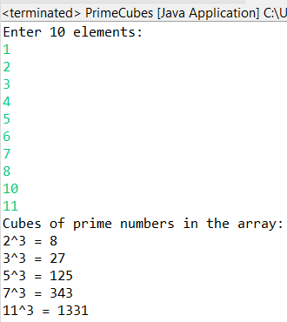

1. Write a java program to implement integer wrapper class methods.(any 3 methods)

# CODE :

**package** Hellow;

**public class** IntegerWrapperClassMethods {

**public static void** main(String[] args) {

// Method 1: parseInt String numberStr = "1505";

**int** number = Integer.*parseInt*(numberStr); System.***out***.println("Parsed integer: " + number);

// Method 2: toString

**int** anotherNumber = 500;

String anotherNumberStr = Integer.*toString*(anotherNumber); System.***out***.println("Integer to string: " + anotherNumberStr);

// Method 3: compareTo Integer num1 = 100; Integer num2 = 200;

**int** comparisonResult = num1.compareTo(num2);

**if** (comparisonResult < 0) {

System.***out***.println(num1 + " is less than " + num2);

} **else if** (comparisonResult > 0) {

System.***out***.println(num1 + " is greater than " + num2);

} **else** {

System.***out***.println(num1 + " is equal to " + num2);

}

}

}

# OUTPUT :

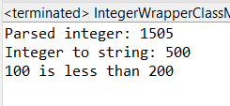

1. Write a java program to implement double wrapper class methods.(any 3 methods)

# CODE :

**package** Hellow;

**public class** DoubleWrapperClassMethods {

**public static void** main(String[] args) {

// Method 1: parseDouble String doubleStr = "123.45";

**double** number = Double.*parseDouble*(doubleStr); System.***out***.println("Parsed double: " + number);

// Method 2: toString

**double** anotherNumber = 456.78;

String anotherNumberStr = Double.*toString*(anotherNumber); System.***out***.println("Double to string: " + anotherNumberStr);

// Method 3: compareTo Double num1 = 100.25; Double num2 = 200.50;

**int** comparisonResult = num1.compareTo(num2);

**if** (comparisonResult < 0) {

System.***out***.println(num1 + " is less than " + num2);

} **else if** (comparisonResult > 0) {

System.***out***.println(num1 + " is greater than " + num2);

} **else** {

System.***out***.println(num1 + " is equal to " + num2);

}

}

}

# OUTPUT :

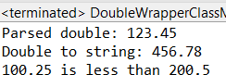

1. Write a java program to implement float wrapper class methods.(any 3 methods)

# CODE :

**package** Hellow;

**public class** FloatWrapperClassMethods {

**public static void** main(String[] args) {

// Method 1: parseFloat String floatStr = "123.45";

**float** parsedFloat = Float.*parseFloat*(floatStr); System.***out***.println("Parsed float: " + parsedFloat);

// Method 2: isNaN

Float nanValue = Float.***NaN***; System.***out***.println("Is NaN: " + nanValue.isNaN());

// Method 3: compareTo Float num1 = 100.25f; Float num2 = 200.50f;

**int** comparisonResult = num1.compareTo(num2);

**if** (comparisonResult < 0) {

System.***out***.println(num1 + " is less than " + num2);

} **else if** (comparisonResult > 0) {

System.***out***.println(num1 + " is greater than " + num2);

} **else** {

System.***out***.println(num1 + " is equal to " + num2);

}

}

}

# OUTPUT :

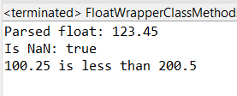

1. Write a Java program to validate email addresses using regular expressions. The email should have the format [username@domain.com](mailto:username@domain.com) where username and domain can contain alphanumeric characters, dots, and hyphens.

# CODE :

**package** Hellow;

**import** java.util.regex.Matcher; **import** java.util.regex.Pattern; **import** java.util.Scanner;

**public class** EmailValidator {

// Regular expression for validating email addresses

**private static final** String ***EMAIL_REGEX*** = "^[a-zA-Z0-9._-]+@[a-zA-Z0-9.-

]+\\.[a-zA-Z]{2,}$";

**public static void** main(String[] args) { Scanner scanner = **new** Scanner(System.***in***);

// Input email address

System.***out***.print("Enter an email address to validate: "); String email = scanner.nextLine();

// Validate email address

**if** (*isValidEmail*(email)) {

System.***out***.println("The email address is valid.");

} **else** {

System.***out***.println("The email address is invalid.");

}

scanner.close();

}

// Method to validate email address using regex

**public static boolean** isValidEmail(String email) { Pattern pattern = Pattern.*compile*(***EMAIL_REGEX***); Matcher matcher = pattern.matcher(email); **return** matcher.matches();

}

}

# OUTPUT :

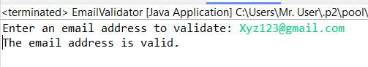

1. Create a Java program to validate phone numbers. The format should be (xxx) xxx-xxxx where x is a digit.

# CODE :

**package** Hellow;

**import** java.util.Scanner;

**import** java.util.regex.Pattern;

**public class** PhoneNumberValidator {

// Regular expression for validating phone numbers

**private static final** Pattern ***PHONE_PATTERN*** = Pattern.*compile*("^\\(\\d{3}\\)

\\d{3}-\\d{4}$");

**public static void** main(String[] args) { Scanner scanner = **new** Scanner(System.***in***);

xxxx): ");

// Input phone number

System.***out***.print("Enter a phone number to validate (format: (xxx) xxx- String phoneNumber = scanner.nextLine();

// Validate phone number and print result

**if** (***PHONE_PATTERN***.matcher(phoneNumber).matches()) { System.***out***.println("The phone number is valid.");

} **else** {

System.***out***.println("The phone number is invalid.");

}

scanner.close();

}

}

# OUTPUT :

